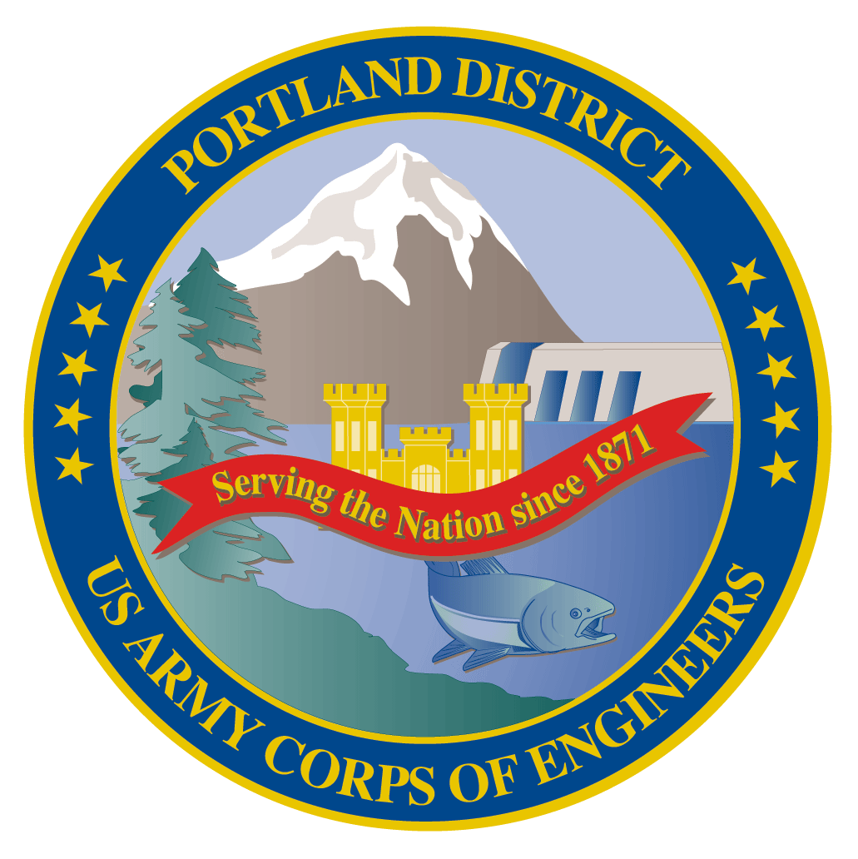
Lower Columbia River Fish Facility Design Review Work Group (FFDRWG)

USACE, Portland District

August 2022 Meeting Notes
August 4, 2022 09:00-11:00

FFDRWG meeting Files
http://pweb.crohms.org/tmt/documents/FPOM/2010/FFDRWG/2022%20FFDRWG/

Introductions
FFDRWG members:
BPA
Scott Bettin
Kim Johnson
Siena Lopez-Johnston
Christine Petersen
Greg Smith
Leah Sullivan
Ben Hausmann
NOAA
Blane Bellerud
Gabriel Brooks
Trevor Conder
Kinsey Frick
Claire McGrath
Kelsey Swieca
USFWS
Dave Swank
Shelby Fowler
States
Erick Van Dyke (ODFW)
Charles Morrill (WDFW)
Jonathan Ebel (IDFG)
CRITFC/Tribes
Tom Lorz (CRITFC)
Blaine Parker (CRITFC)
Tom Skiles (CRITFC)
Laurie Porter (CRITFC)
Greg Silver (CRITFC)
Casey Baldwin (CTCR)
Michael Karnosh (CTGR)
Lawrence Schwabe (CTGR)
Torey Wakeland (CTGR)
Aaron Jackson (CTUIR)
Ralph Lampman (YN)
NPCC
Leslie Bach
Kris Homel
FPC
Erin Cooper
PSMFC
Alan Brower
Darren Chase
Roger Clark
Mark Leonard
Scott Livingston
Nicole Tancreto
Don Warf
CENWD
Doug Baus
Tim Dykstra
Dan Feil
Cindy Studebaker
Lisa Wright
CENWW
Steve Sipe
Chris Peery
Steve Juhnke
CENWP-OD
Andrew Derugin
Rebecca Cates
Jeanette Wendler
Tucker Gossett
Bob Cordie
Jeffrey Randall
Eric Grosvenor
Michael Lotspeich
Laura Rickets
Tammy Mackey
Robert Wertheimer
Patricia Madson
Darren Gallion
CENWP-PM
Jim Adams
Ian Chane
Jeff Hicks
Jeremiah Woodard
Erin Kovalchuk
Mark Bierman
Brad Eppard
Nathan McClain
Jake Macdonald
Jon Rerecich
Ida Royer
David Trachtenbarg
Scott Fielding
CENWP-ENC
Adam White
Brandt Bannister
Bridget Bell
Shari Dunlop
Curtis Lipski
Chris Motti
Steve Schlenker
Max Wilson-Fey
Collin Porter
Dan Penn

*Present

Action items from previous meetings
- Corps will present The Dalles backup AWS debris management alternatives at an upcoming FFDRWG (EDR shelved at 50% with no funding in FY 22 until recently).
  - Project is reactivated and the Corps (Rerecich) will walk through 60% alternatives with FFDRWG at the September 1st meeting.
- TDA lamprey PDT will discuss FFDRWG’s recommended option for exit weirs 154-157 (option #3, spacer attached to the bottom of the weirs) and Adam White will report any significant developments at the next FFDRWG meeting. (see section 2a below).
- Jake Macdonald will add John Day ladder cooling as a standing topic on the FFDRWG agenda. (see section 4a below).
- Scott Fielding will lead a FFDRWG discussion of the available data for JDA ladder cooling. This discussion will help determine the path forward on design and construction of a ladder cooling structure prior to the FY25 budget request submission in December 2022. (see section 4a below).

Topics for FFDRWG Discussion/Review/Coordination
- BON2 FGE – Jim Adams (PM), Max Wilson-Fey (TL), Jon Rerecich (FC)
  - Update on hydraulic testing – Wilson-Fey
    - Received 4 full spreadsheets (2 for velocity, 2 for pressure) 3 days ago, not ready to share with FFDRWG, needs internal review and interpretation first.
    - Contractor discovered and corrected a slight error in the 2015 data.
    - Scott Bettin (BPA): Can we still work (install in additional units) this Winter IWW? Max: PDT cannot make that call until we receive the final data in a couple months.
    - Tom Lorz (CRITFC): Bummed we can’t see the data today. If the PDT sees something in the data that could delay construction beginning in December, we need a meeting to discuss it sooner than the next FFDRWG (1-Sep).
    - B2 FGE has been a FFDRWG project since the early ‘90’s. FFDRWG wants to get these installed and be done with this so Scott Bettin can enjoy his well-earned impending retirement.
    - Action: Jon and Max will perform a “red flag” review of the preliminary data and report back to FFDRWG via email in 2 weeks (18-Aug)
- BON2 control section redesign – Jeremiah Woodard (PM), Shari Dunlop (TL), Andrew Derugin (FC)
  - 60% DDR is available for FFDRWG review at: http://pweb.crohms.org/tmt/documents/FPOM/2010/FFDRWG/2022%20FFDRWG/
  - Overview of 60% DDR – Dunlop
    - Trevor Conder (NOAA): Will this all be installed in 1 construction window? Shari: Yes, that is still the plan, as discussed in the cost and construction section of the DDR. Constructability is one of the ATR charge questions, it’s still a concern for the PDT.
    - Trevor: How are sockeye and jacks getting in the AWS channel? Possibly under the 1.5 inch gap for lamprey under the picket lead? Tammy Mackey: sockeye were observed in the AWS channel before we lifted the picket leads for lamprey so likely getting in some other way. Few mortalities have been recovered from the upstream side of the picket leads, suggesting they may find their way back out?
    - The BON2 control section redesign project scope is upstream of the count station and does not include the AWS channel.
    - Dave Swank (USFWS): Are slot velocities and orifice velocities higher or lower than the current slot velocities. Schlenker/Dunlop: somewhat higher through some of the slots but orifice velocities should be similar to the current slot velocities. Velocity is a function of head drop. The proposed design has fewer weirs with a larger head differential than the current design. The individual “challenges” may be a little more difficult but there will be fewer challenges to negotiate over a shorter overall travel distance.
    - Hydraulic model is being set up to allow velocity comparison. Results will be shared at an upcoming FFDRWG (not September, maybe October).
    - Trevor Conder (NOAA) needs more justification of the benefits of this project for lamprey and for salmonids.
    - ACTION: Nathan McClain and Jake Macdonald will summarize the available information supporting our expectation of a substantial boost to lamprey passage success combined with a benefit to salmonid passage at an upcoming FFDRWG meeting.
- (it’s back!!) TDA Backup AWS debris management – Erin Kovalchuk (PM), Mehdi Roshani (TL), Jon Rerecich (FC)
    - Presentation of 60% alternatives at the September 1st FFDRWG - Rerecich
    - End of January – alternatives evaluation report, End of October – final report
    - Tom Lorz (CRITFC): please send out the latest report again.
    - ACTION: TDA AWS backup debris management PDT will send the current draft as a read-ahead for September 1st FFDRWG.
      - 50% EDR and alternatives ranking matrix are available on the FFDRWG website: http://pweb.crohms.org/tmt/documents/FPOM/2010/FFDRWG/2022%20FFDRWG/
- JDA adult lamprey passage improvements – Jeremiah Woodard (PM), Adam White (TL), Jake Macdonald (FC)
  - 60% DDR available for FFDRWG review at: http://pweb.crohms.org/tmt/documents/FPOM/2010/FFDRWG/2022%20FFDRWG/
    - In-house construction, no 90% DDR and no BCOES, straight from 60% to 100%. Construction in Winter 2022-2023.
- TDA adult lamprey passage improvements – Jeremiah Woodard (PM), Adam White (TL), Jake Macdonald (FC)
  - 60% DDR available for FFDRWG review at: http://pweb.crohms.org/tmt/documents/FPOM/2010/FFDRWG/2022%20FFDRWG/
    - PDT discussed alternatives for lamprey passage through the EFL exit weirs and decided notching the bottom corners of the weirs has the least potential for negative impacts. A sill on the bottom of the weirs or the fishway floor would raise the elevation of the overflow weir crests and could possibly reduce flow depth over the weirs. The PDT prefers the notching alternative because the overflow weirs remain at their designed elevation (Steve Schlenker).
- BON1 adult lamprey passage improvements – Jeremiah Woodard (PM), Adam White (TL), Andrew Derugin (FC)
  - 60% DDR available for FFDRWG review at: http://pweb.crohms.org/tmt/documents/FPOM/2010/FFDRWG/2022%20FFDRWG/
- Other topics
  - John Day Ladder Cooling
    - JDA project staff are collecting forebay temperature profiles near the South Ladder exit in 2022. Same location as JDA-SS-2 from the 2018 Lundell report (https://pweb.crohms.org/tmt/documents/FPOM/2010/FFDRWG/2021%20FFDRWG/2019_Temp_Profile_Study_LCOR_Forebays_Final_Nov2019.pdf)
    - JDA project staff are also testing “shad mode” as a means to reduce temperature differentials and max temps.
    - ACTION: FFDRWG will review 2022 temperature data and shad mode test results in September and October, then provide a recommendation to the CRFM Program Manager for the initial FY 2025 budget capability submission due on 18-November.
  - BON Spillway rock removal & prevention
    - Hydro survey scheduled for 1-September to determine the quantity of rock to be removed.
    - Contract for removal to be awarded 21-Nov. Removal to take place during IWW.
    - ACTION: USACE (Jake, Jon, Max, Erin, or ??) will provide an update on the rock *prevention* PDT at the 1-September FFDRWG meeting.

